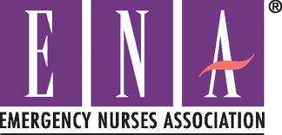

WNY Emergency Nurses Association Briefing February 2014

Meeting Content Thank you Julie Beale from Medicines Company who presented information and treatment on hypertension by use of Cleviprex.
.

Website
www.wnyena.com.

Home page connects WNY ENA with links to national ENA and membership.
This site has guides to classes, conferences, registration, downloadable forms and future meetings.

2014 Officers

President – Renee Sylvies, RN
Treasurer – Roseann Mohney, RN
Secretary – Sharon Lanich, RN
National ENA Conference

October 7-11, 2014 in Indianapolis, IN. More information to follow.

CEU’s

Go green! CEU’s available online at http://nursece4less.com/

EDUCATION ENPC class dates: 9/9/14 - 9/10/14

Deadline 8/9/14

TNCC class dates: 10/27/14 - 10/28/14

Next Meeting

August 13, 2014 at Erie County Fire Academy, Speaker Sally Broad Attorney

Elections: August 13, 2014

